Apache OFBIZ PROJECT

**The Apache OFBIZ project is an Ecommerce website. We are using six services to deploy a project in Amazon web services.**

1. **Amazon web services. (Ec2 instances, VPC, security groups, RDS, Network ACL’S).**
2. **Apache or HTTPD web server.**
3. **RDS (Relation database service {MYSQL})**
4. **SSL using mod_ssl.so module and mod_perl.so.**
5. **Java jdk1.8.0-openjdk**
6. **FileZilla or WinSCP (To transfer files to Aws Ec2 instance server).**

**Amazon web services:**

**To deploy OFBIZ project we want to create Ec2 instances and choose Ram size to run a project without Errors.**

**Steps to create Ec2 instance and clone a OFBIZ project from GitHub to Ec2 instance:**

1. **Choose launch Ec2 instances.**
2. **Choose Ec2 instances OS Type as a “Amazon Linux2 “free tier eligible and Choose Size of Ec2 instance like t2. micro with 2gb Ram.**
3. **And choose Ec2 Region ap-south-1 and Choose storage space like 8GB.**
4. **Add security groups to Ec2 instances to open putty we need to add ports 22 and 80.**
5. **Add tag to Ec2 instance tag means name of the Ec2 instances.**
6. **Specify the Ec2 instance name as a ofbiz and create a Keypair for Ec2 instance.**
7. **Launch Ec2 instances and Refresh the Ec2 instance and check it will Reach the AWS data Centre by getting 2/2 checks. And attach Elastic Ip address to Ec2 instance.**
8. **Convert Ec2 instance keypair from. PEM Extension to. PPK by using puttygen.**
9. **Login to Ec2 instance using putty and Ec2 IP address and keypair.**
10. **Ec2-user is login user name for Ec2 instance and login to root by using command Sudo su -.**
11. **And clone the Ofbiz project from GitHub to Ec2 instances by using following commands:**

**We need to create repository in GitHub “testofbiz”**

**And Install git in local Machine and Open “GitBash command line”.**

**Give the command “GIT INIT” TO Create a new. git folder under C:/user/Nz215/.git/.**

**Give “GIT ADD. README.md” command to add readme file to git.**

**Commit the files to add to GITHUB Account by using command “GIT COMMIT -FIRST COMMIT”.**

**And connect by adding to. git by using a command “git remote add origin** <https://github.com/sumit/sumit.git>**”.**

**Now push the “APACHE OFBIZ PROJECT FOLDER TO GITHUB” Using a command “git push -u origin master”.**

**Now login to Ec2 instance and configure with GITHUB by using below commands.**

**git config –global user. Email”** [sumitkatiyar9@gmail.com](mailto:sumitkatiyar9@gmail.com)**”**

**git config –global user.name “xxxxx”**

**git clone** <https://github.com/sumitofbiz/testofbiz.git>**.**

1. **After Cloning the Ofbiz project from GitHub to Ec2 instance Give permissions to Apacheofbiz16.04 folder by using command “chmod -R 777 folder name “.**

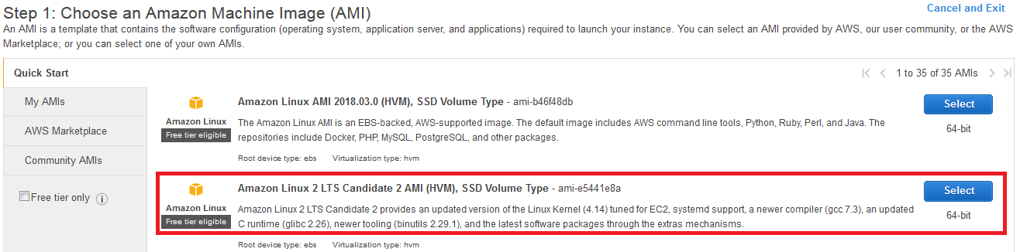

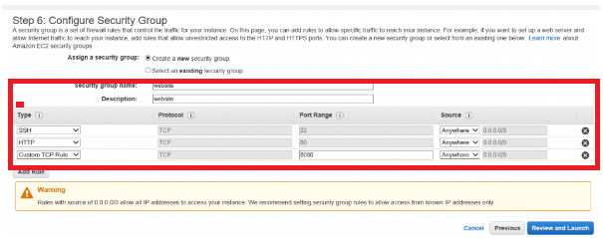

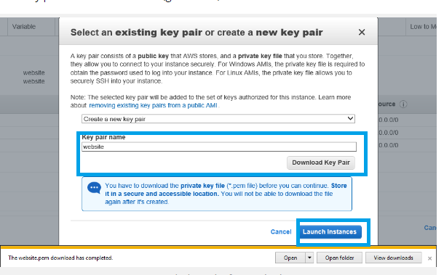

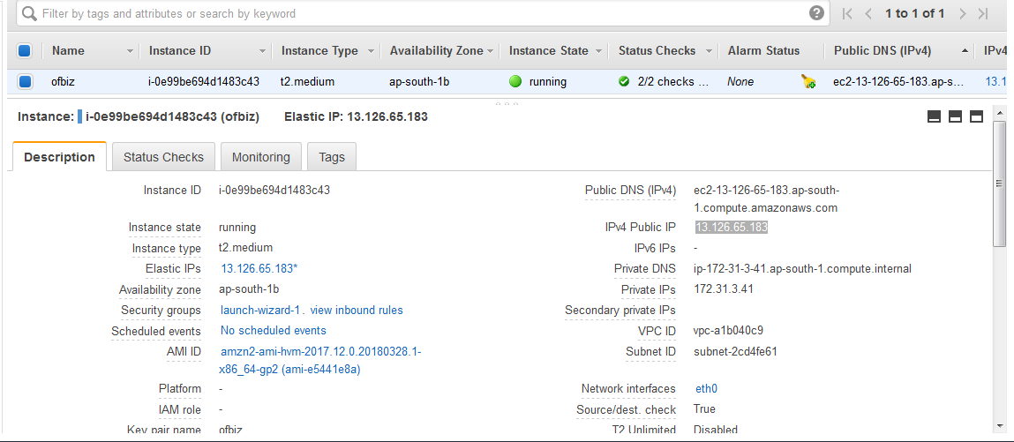

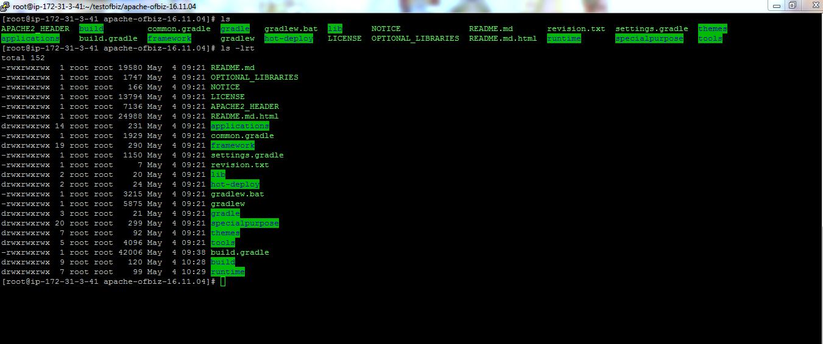

**PORT NUMBERS OF OFBIZ:**

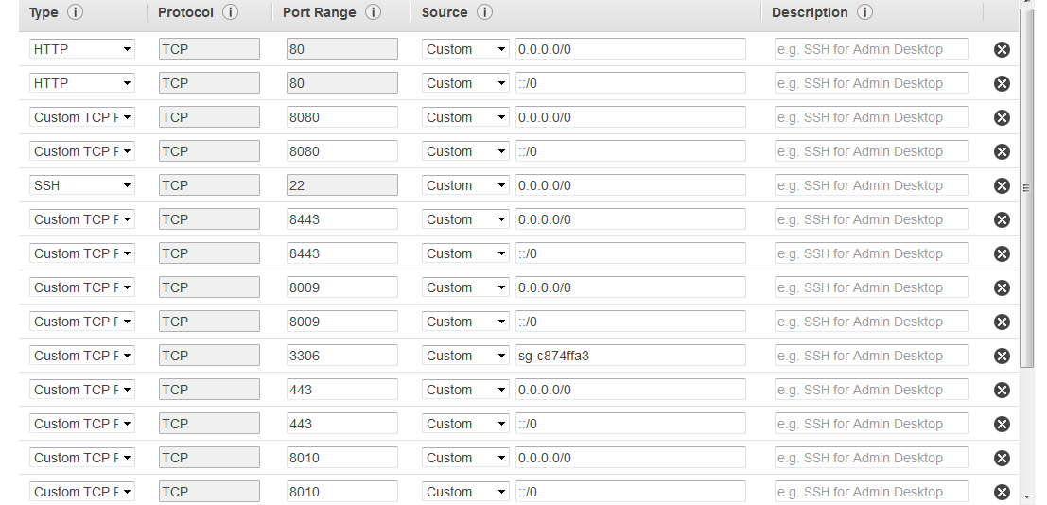

**NETWORK ACL’S:**

**AWS Network ACL’s (Network Access control list) is a firewall that controls the traffic and we can block any IP address to protect our websites securely in AWS. We can simply add IP address in it and add “DENY” to block IP Address.**

**Steps to use NETWORK ACL TO BLOCK IP ADDRESS:**

1. **RULE: Use any number less than 100, which is the number of the default accept-all rule. This is important because rules are evaluated in order, and your rule needs to come before the default.**
2. **TYPE: ALL TRAFFIC**
3. **PROTOCOL: LOCKED TO “ALL”**
4. **PORT RANGE: SELECT ALL**
5. **SOURCE:**

**The CIDR you want to block. To match a single IP address, enter it here and append /32. For example, I blocked 86.98.149.37/32.**

1. **ALLOW / DENY: Select “DENY” to block IP address. If u want to allow IP address to access application Choose “ALLOW”.**

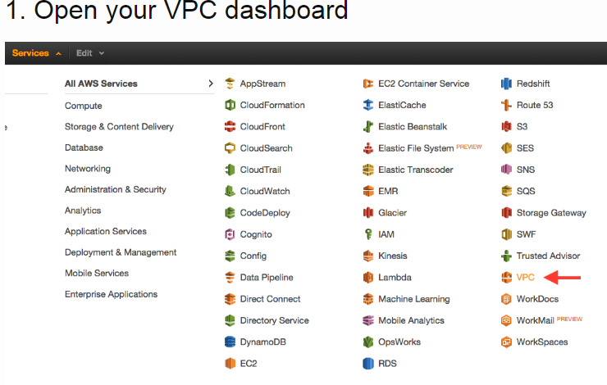

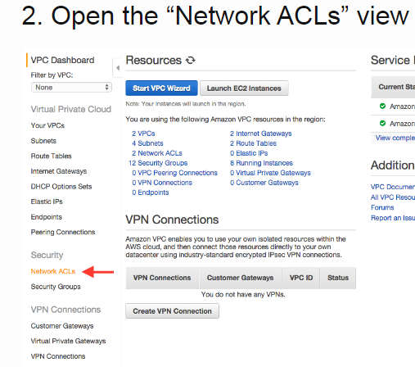

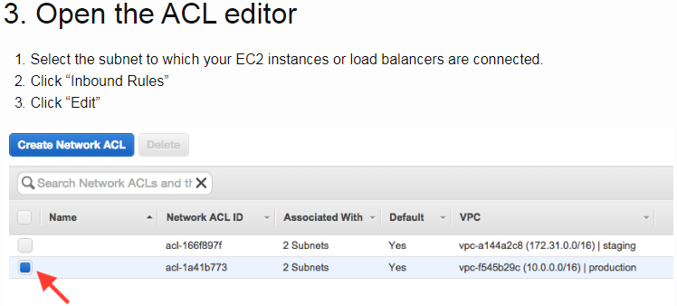

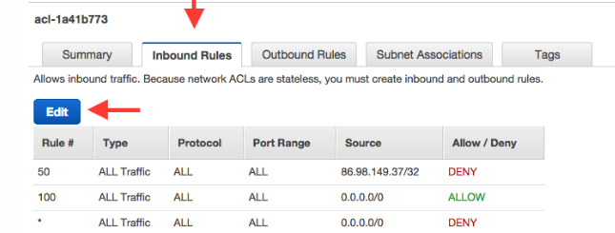

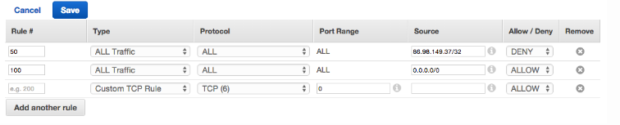

**JAVA JDK INSTALLATION IN Ec2 Linux:**

**Java jdk 1.8.0 is the main configuration to start the ofbiz project in Linux. we need to install the java jdk 1.8.0 latest version and we need to setup the path of java.**

1. **We need to search the java latest version for ofbiz project by using a command “yum search all jdk 1.8.0**

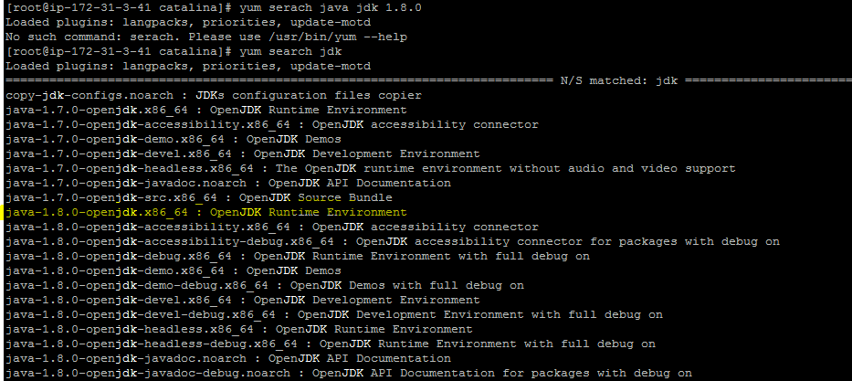

1. **We need to choose java -1.8.0-openjdk and we need to install java by using a command “YUM INSTALL JAVA-1.8.0-OPENJDK”.**
2. **By default, it will install under the cd /usr/sbin/java.**
3. **We need to check java is installed or not using a command “WHICH JAVA”. It will show the location of java installation. And check java version “JAVA -VERSION” COMMAND.**
4. **Now after installation we need to set the java path in Linux Ec2 using a command**

**“find /usr/lib/jvm/java-1.8.0-openjdk**

**Edit the /etc /profile with Nano or vim commands.**

1. **And add the path of java location to profile file**

**Export JAVA_HOME=” path of java location”**

**Export PATH = $ JAVA_HOME/BIN: $PATH.**

1. **Reopen the shell or use source /etc/profile to apply changes immediately.**
2. **And now go to the ofbiz project location and start the project using a command**

**“. /gradlew ofbiz.**

**Apache Webserver:**

**The Apache webserver is the main configuration server to run an Apache Ofbiz project in Amazon web services. We need to Install httpd in Ec2 instances.**

**Steps to Configure Apache or HTTPD webserver:**

1. **First, we need to search HTTPD webserver to install in Ec2 instance by using command “Yum search all HTTPD”. We will get output like following screenshot.**

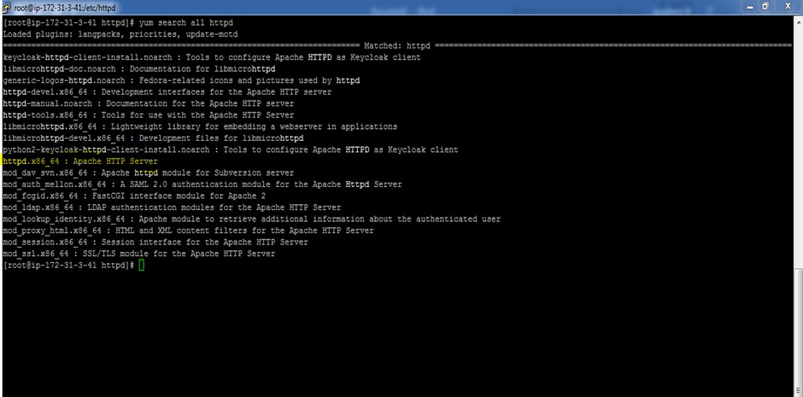

1. **We need to choose “httpd.x86_64”: Apache http server from list.**
2. **And install httpd by using “Yum -y install httpd”. By default, it will install under /etc/httpd.**

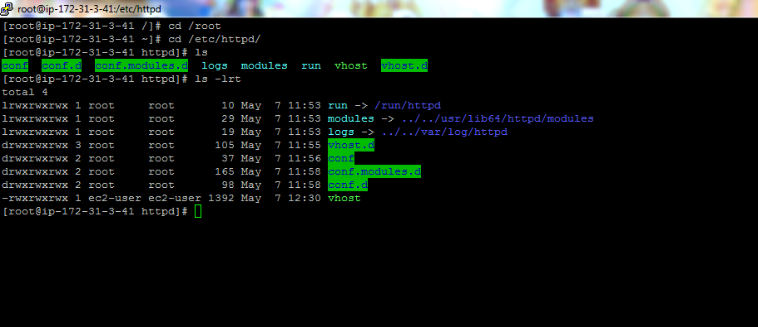

**If we need the PROCESS ID for the apache webserver use the command “PS -EF | GREP HTTPD”.**

**OUTPUT:**

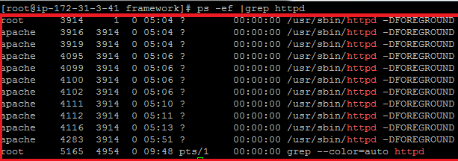

**And sometimes we will reload apache webserver and restart some many times whenever we do changes in httpd.conf file or any files. If the process is changed we will got “APACHE STATUS FAILED”. To Debug this Error, we need KILL PROCESS ID’S. we need to use command kill pid’s**

**“KILL -9 PID” 🡪 It will kill only Process id**

**“KILL -15 PID” 🡪 It will kill the child process first and then it will kill parent (main) process id.**

**After Killing also sometimes httpd will not start at that time we need to use command “KILLALL HTTPD”.**

1. **Start Apache web server by using “service httpd start”. And we can status of running apache suing command “apachectl status”.**

**OUTPUT:**

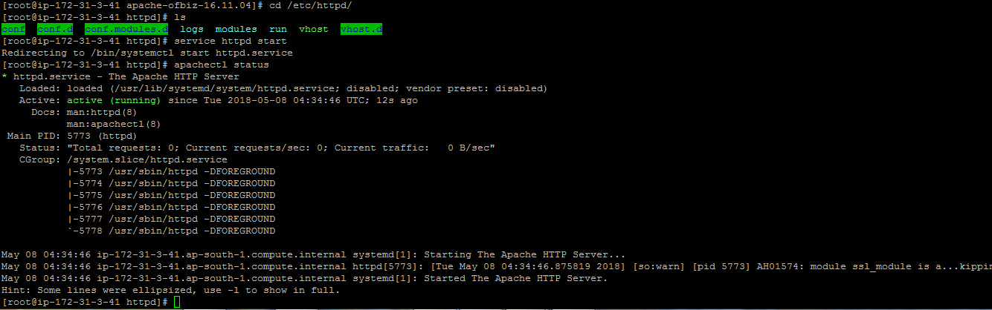

1. We need to create some vhost file and vhost.d directory to run a ofbiz using Apache webserver. By using command “touch” and mkdir commands.
2. Vhost file
3. Vhost directory
4. Under vhost directory we need to create some configuration files and includes folder.
5. [www.newsatllc.com-ssl.conf](http://www.newsatllc.com-ssl.conf)
6. V2host_a2ensite.conf
7. Newsatllc.com.conf

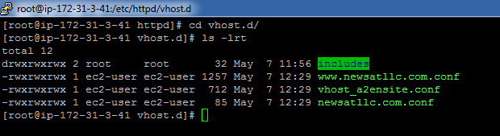

1. We need to create newsatllc.com.conf file under the vhost.d/includes folder.
2. Now after creating configuration files we need to add our virtual host config in all files.

Output of vhost file:

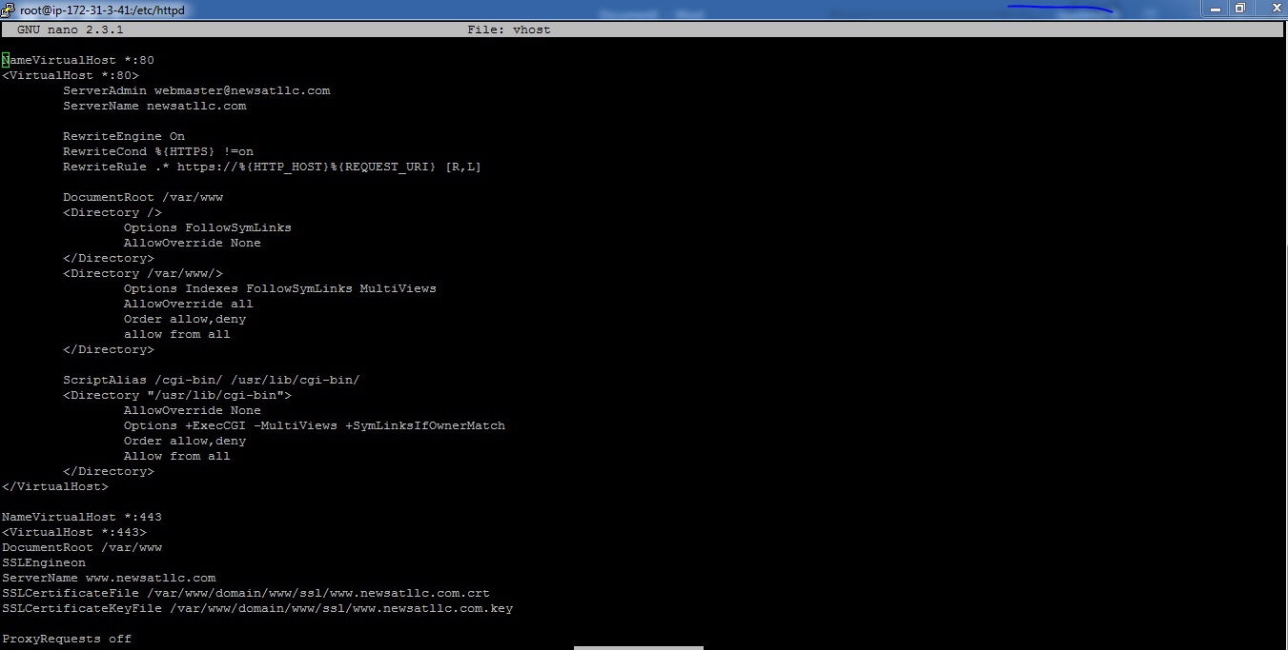

1. We need to add our domain and document root and SSL configuration in every config files under the vhost.d folder and includes folder.

Output of v2host file:

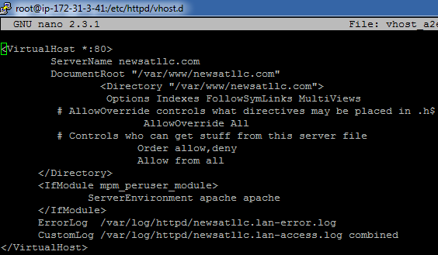

1. Under /etc/httpd/conf folder we have main configuration file called “httpd.conf “ file. In this file we need to add our Ec2 instance IP address and domain name to connect with our ofbiz project.

Under Listen section we need to add Ec2 IP address [13.126.65.183](https://ap-south-1.console.aws.amazon.com/ec2/v2/home?region=ap-south-1#Addresses:search=13.126.65.183;sort=publicIp):80

Under server email address we need to email “ [webmaster@newsatllc.com](mailto:webmaster@newsatllc.com)”

Under server name we need to add our domain name with port number like “ [www.newsatllc.com:80](http://www.newsatllc.com:80)”.

1. We need to create configuration files and SSL certificates under /var/www folder.

Output:

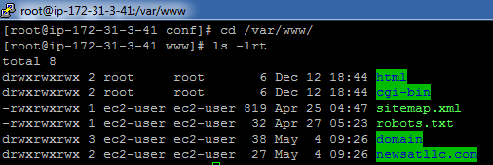

1. Files we need to create under cd /var/www/
2. Sitemap.xml
3. Robots.txt
4. Folder newsatllc.com.
5. Inside the newsatllc.com file we need to create file called “newsatllc.com “and we need to provide path of file in vhost file under /etc/httpd.
6. And we need to add local IP address with domain name j2ee.www.newsatllc.com and with Ec2 IP address with www. Newsatllc.com in main config “HOSTS FILE” under /etc/hosts file. We need to edit file using command Nano hosts.

Output of hosts file:

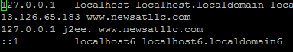

1. And we need to install SSL module to configure SSL with ofbiz project using https.
2. And finally, we need to add proxy pass and proxy ajp to redirect the domain and add the robots.txt and sitemap.xml location to block the robots to access the application.
3. We need to set the server admin as an Email id “ [WEBMASTER@NEWSATLLC.COM](mailto:WEBMASTER@NEWSATLLC.COM)”.
4. AND In httpd.conf file we need to add our domain name under server name “ [WWW.NEWSATLLC.COM:80](http://WWW.NEWSATLLC.COM:80)” TO redirect our domain from webserver.

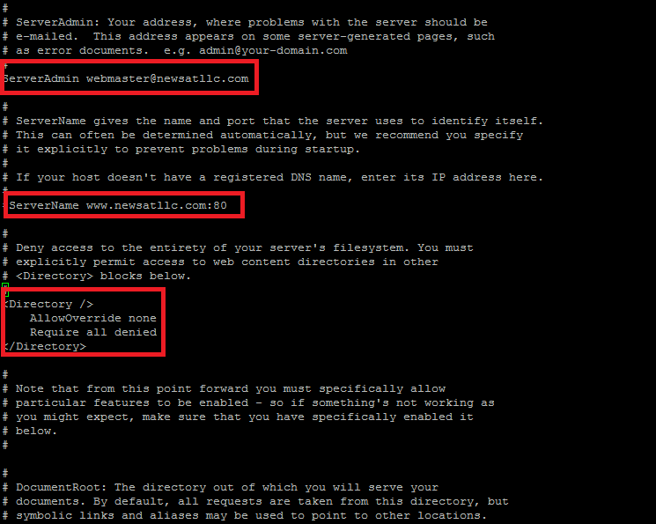

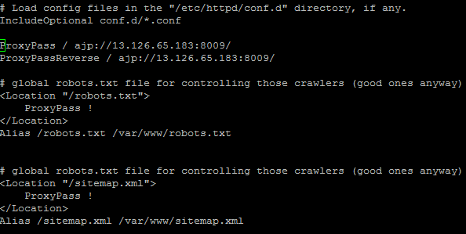

ROBOTS.TXT:

What is robots.txt?

Robots.txt is a text file webmaster create to instruct web robots (typically search engine robots) how to crawl pages on their website. The robots.txt file is part of the robot’s exclusion protocol (REP), a group of web standards that regulate how robots crawl the web, access and index content, and serve that content up to users. The REP also includes directives like meta robots, as well as page-, subdirectory-, or site-wide instructions for how search engines should treat links (such as “follow” or “no follow”).

In practice, robots.txt files indicate whether certain user agents (web-crawling software) can or cannot crawl parts of a website. These crawl instructions are specified by “disallowing” or “allowing” the behaviour of certain (or all) user agents.

We need to create robots.txt file in httpd apache webserver under /var/www/robots.txt. And we need add the path of robots.txt in the httpd.conf file. And if we type in Browser [WWW.NEWSATLLC.COM/ROBOTS.TXT](http://WWW.NEWSATLLC.COM/ROBOTS.TXT). It will show out as shown below in screenshot.

Output:

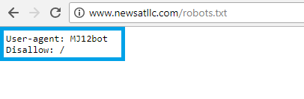

SSL CONFIGURATION WITH OFBIZ:

1. SSL configuration is the main part of ofbiz project to secure the website and for SSL we need to install mod_ssl.so module and SSL.conf file.
2. We need to search for mod_ssl.so module using command “yum search all mod_ssl”.

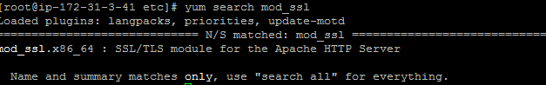

1. We need to install mod_ssl.X86_64 module for https by using command “yum -y install mod_ssl. soX86_64.”
2. And installing mod_ssl module by default it will install under the /etc/httpd/modules/mod_ssl.so.
3. And when we install this module we will get ssl.conf file to configure ssl certificates. Ssl.conf will be under the /etc/httpd/conf.d/ssl.conf file.
4. In the SSL Conf file we need to add our Server name as our domain name [www.newsatllc.com:443](http://www.newsatllc.com:443) and we need to provide the document root “/var/www/html”.
5. In ssl.conf file we need to provide the path of the SSL certificates path under sslEngineon section.

Output of ssl conf file:

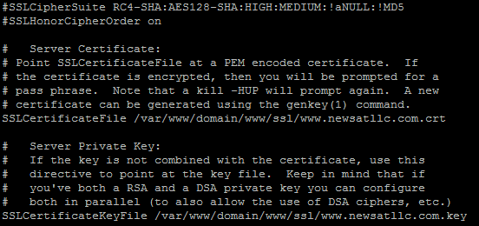

1. We need to ssl certificates path in [www.newsatllc.com-ssl.conf](http://www.newsatllc.com-ssl.conf) file under the /etc/httpd/vhost.d folder.

RDS (RELATIONAL DATABASE SERVICE):

Amazon RDS (Relational database service) is the webservice that makes it easier setup, operate and scale a relational database in the AWS Cloud. It provides cost efficient, resizable capacity for storage and makes easier to check access and error logs and database administrative tasks.

How to setup RDS in AWS and connect with ofbiz:

🡪 Login to aws console and go to services and open the RDS.

🡪 click the “Launch Aurora DB instance” and Choose the database like MySQL, oracle or amazon aurora.

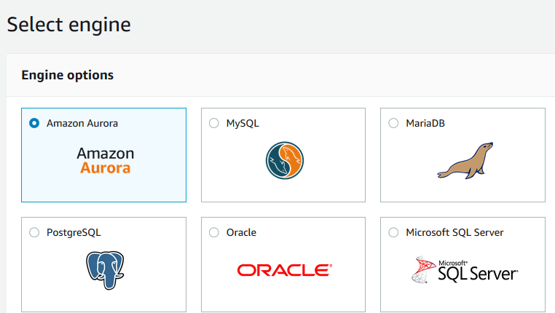

🡪 choose MySQL and click on Next choose USE CASE as DEV/TEST -MYSQL for the free tier usage purpose.

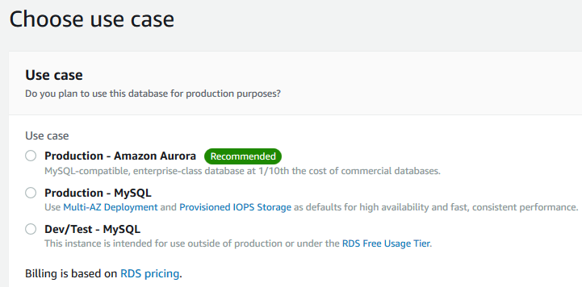

🡪 Click on Next and specify DB details like Engine name and DB instance class as a t2. micro.

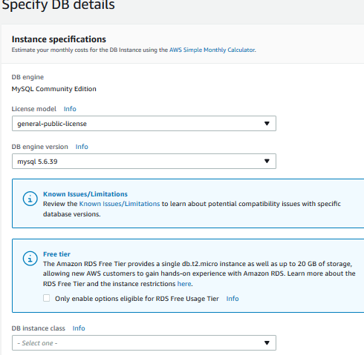

🡪 And specify the user name and password and confirm password and choose the storage space 10gb.

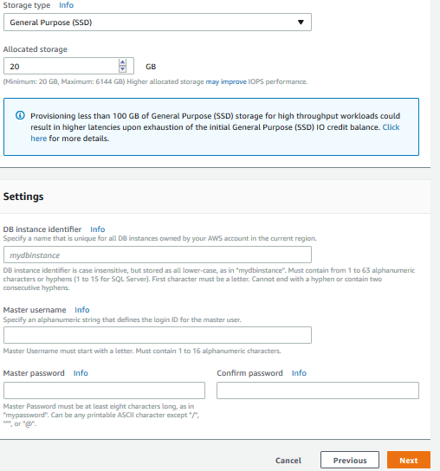

🡪 And Click on next review all the settings and choose database settings port number version and logs.

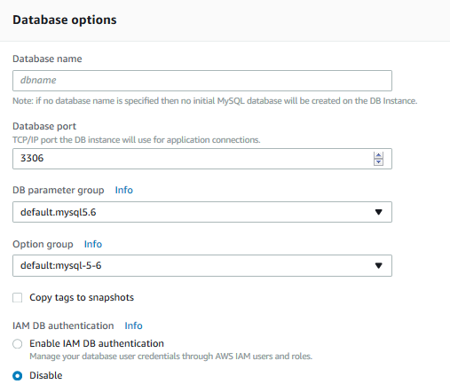

🡪 Launch the DB instances and check it is available and active state.

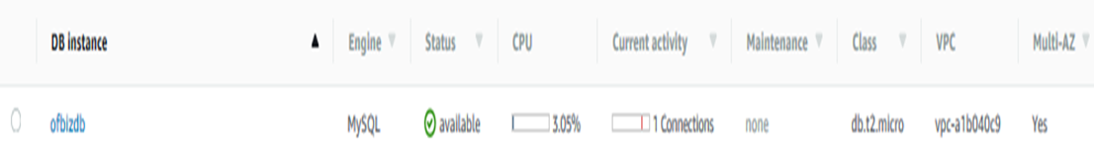

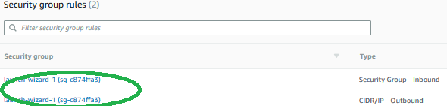

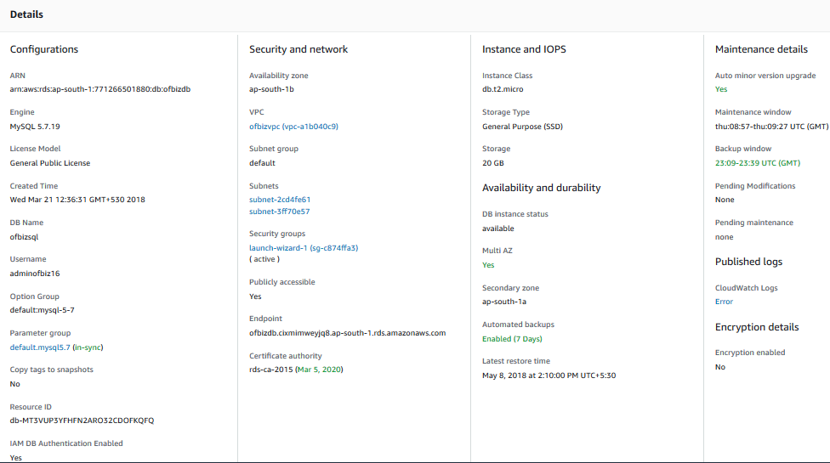

🡪 And connect RDS with Ec2 instance by adding port numbers under Ec2 MYSQL “3306” and we need add db instance security group “sg-c874ffa3”.

🡪 And login to putty with Ec2 IP address and keypair and check DB relates to Ec2 instance by using a command

“mysql -h ofbizdb.cixmimweyjq8.ap-south-1.rds.amazonaws.com -u adminofbiz16 -p -D ofbizsql “and enter the password and check the databases using a command “SHOW DATABASES”.

Output of RDS in EC2:

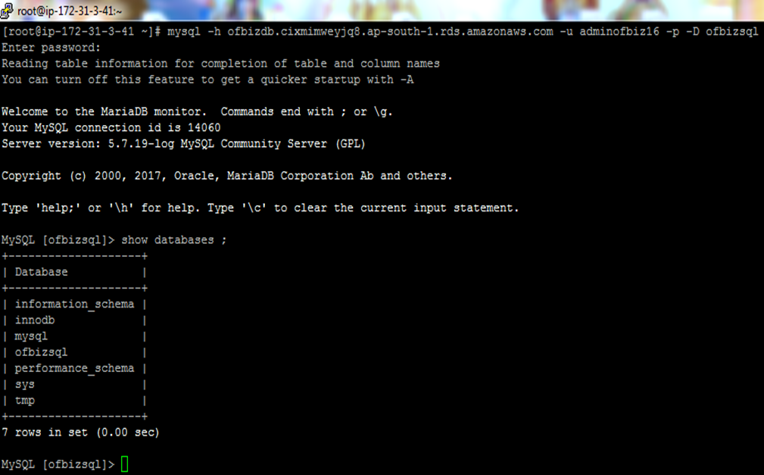

🡪After connecting with command to rds check the db. instance in aws console where it is connected or not it will show “connections 1”.

Steps to dump the MySQL ofbiz data to AWS RDS:

If We need to dump the Ofbiz MYSQL backup data to Amazon RDS. We need to use the commands and we need to set the Amazon RDS host name in the Entityengine.xml file in ofbiz.

1. First, we need to create the connect our AWS RDS using command 
2. And now we need to check our main database is available or not using command “show databases” and quit the RDS using “\q” command.
3. And now we need to dump the ofbiz MYSQL data to AWS RDS we need to use command

“MySQL -hostname ofbizdb.cixmimweyjq8.ap-south-1.rds.amazonaws.com -u adminofbiz16 -p and database name “ofbizsql “< backup.sql.

1. And specify the RDS host name in Entityengine.xml file under /apacheofbiz16.04/framework/ entity/ config/entityengine.xml. and remove Derby default database and specify local MySQL.

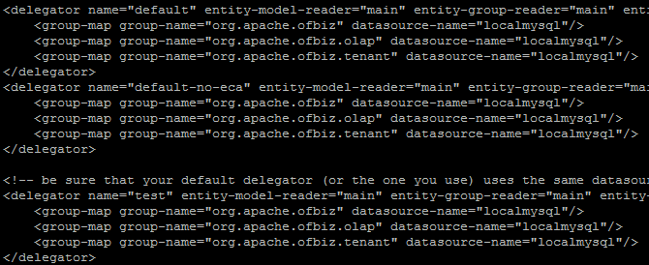

1. Specify RDS details like username, password, database name and hostname of RDS.

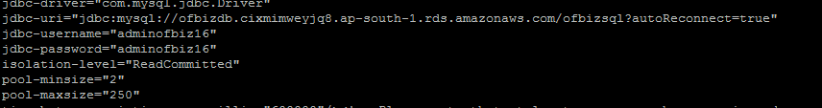

Ofbiz project settings:

In the Ofbiz project we need to set the domain in the ofbizcontainers.xml file and we need to set the port numbers and adding domain in the for the SSL in URL Properties.

In ofbizcomponent.xml file under ajp connector we need to specify our domain name

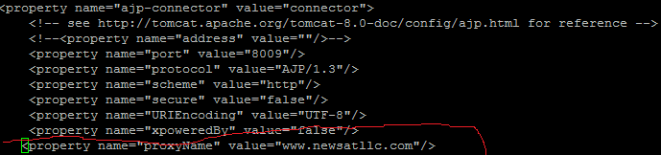

We need to specify the domain name with j2ee in ofbizcomponent .xml file under http connector and https connector.

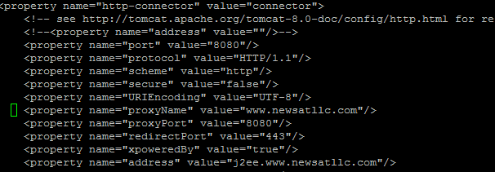

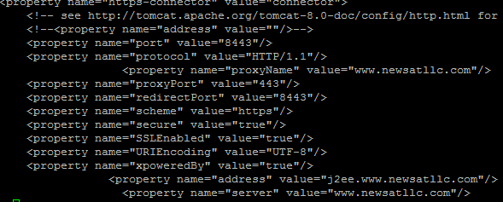

We need to add our domain name under the cd /framework/webapp/config/URL. Properties file.

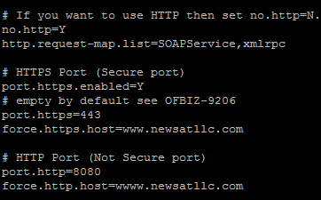

Now we are ready to access the OFBIZ Application with our domain name.

Start the Apache webserver first using command “service HTTPD start “and check the status whether it is running or not with command “apachectl status”.

And connect the RDS Database and login to our main database “show databases and use ofbizsql”.

Start the ofbiz project by using a command “. /gradlew ofbiz”.

And Access the ofbiz application with domain “https://www.newsatllc.com”.

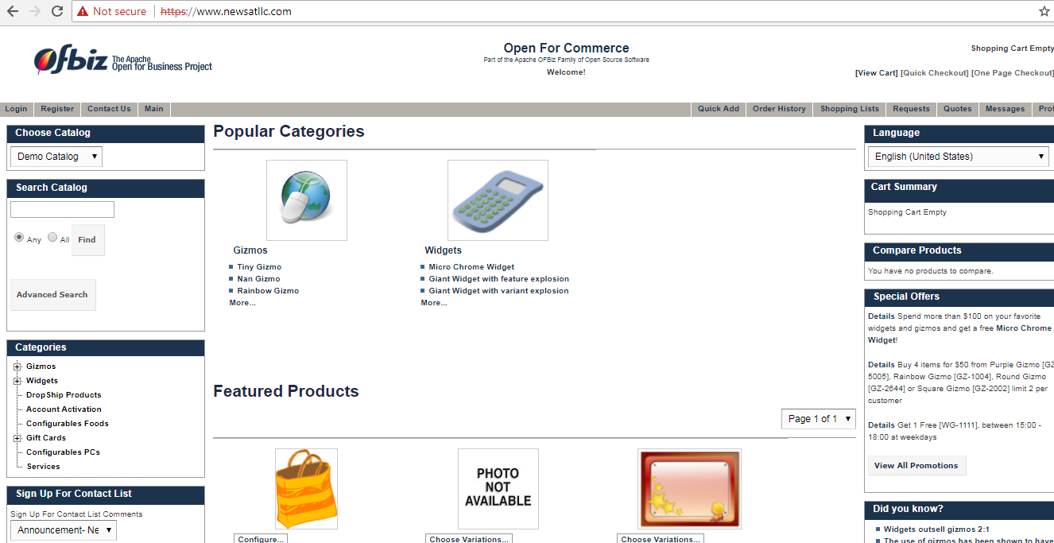

We can register with our email id and username and password. The data will have stored in the RDS. And login with our username and password to our ofbiz application.

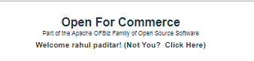

Stored data with our name in AWS RDS

C:\Users\nz215\Desktop\RA.PNG

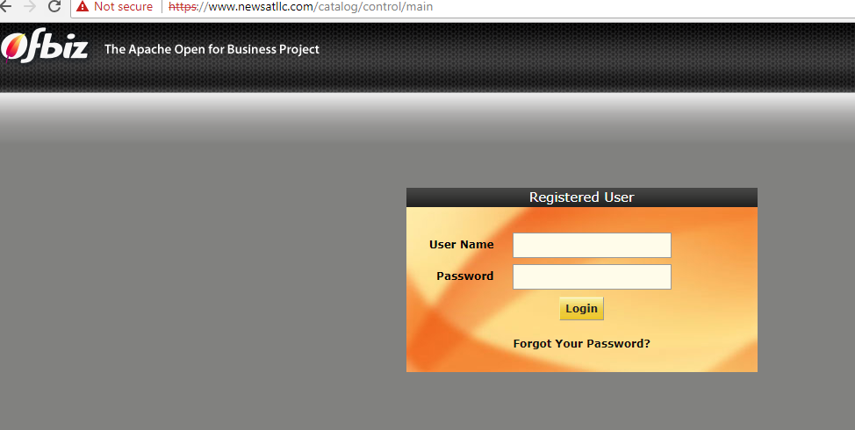

Now login to our domain with username and password credentials.

Username: admin

password: ofbiz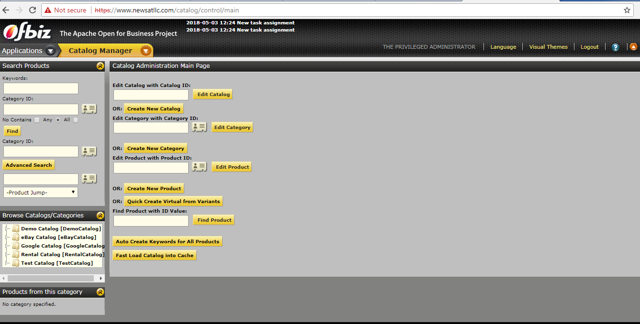

FILEZILLA OR WINSCP:

“FILEZILLA AND WINSCP “are both use to transfer files from local server to AWS Ec2 instance server.

Steps to transfer files from FileZilla to Ec2:

1. Open the FileZilla.

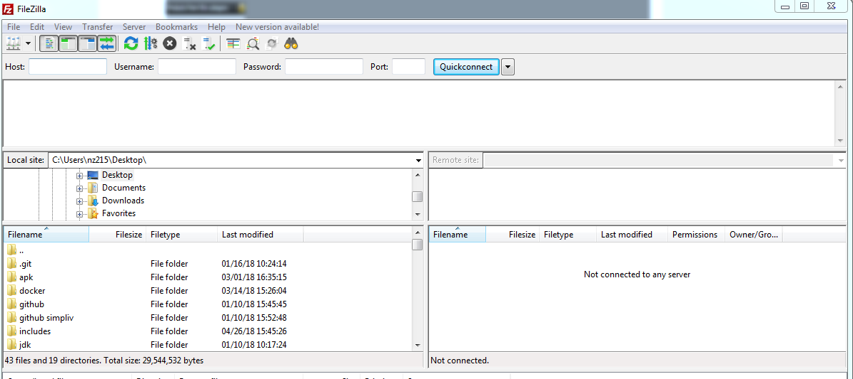

1. copy the Ec2 server IP address “[13.126.65.183](https://ap-south-1.console.aws.amazon.com/ec2/v2/home?region=ap-south-1#Addresses:search=13.126.65.183;sort=publicIp)” and Enter it in host column and Enter the username as “ EC2-USER” and Enter the port number “22” for SFTP.

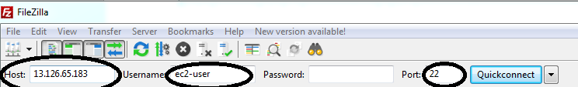

1. we need to add EC2 key pair as a password under “SELECT EDIT 🡪 CONNECTIONS 🡪 CHOOSE SFTP 🡪 SELECT ADD KRY FILE AND BROWSE OFBIZ.PPK EXTENSION FILE AND ADD IT AND SELECT OK AND SELECT QUICK CONNECT. IT WILL CONNECT TO EC2 INSTANCE SERVER.

C:\Users\nz215\Desktop\PPP.PNG

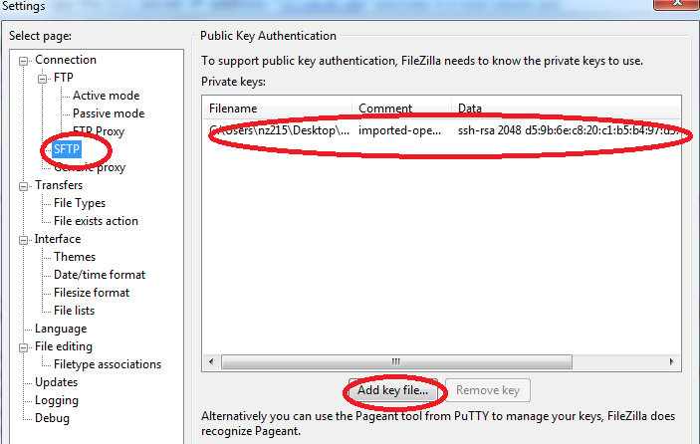

1. Now we connected to Ec2 server using FileZilla. We can see in below screenshot FileZilla successfully connected to local site and EC2 Remote server site.

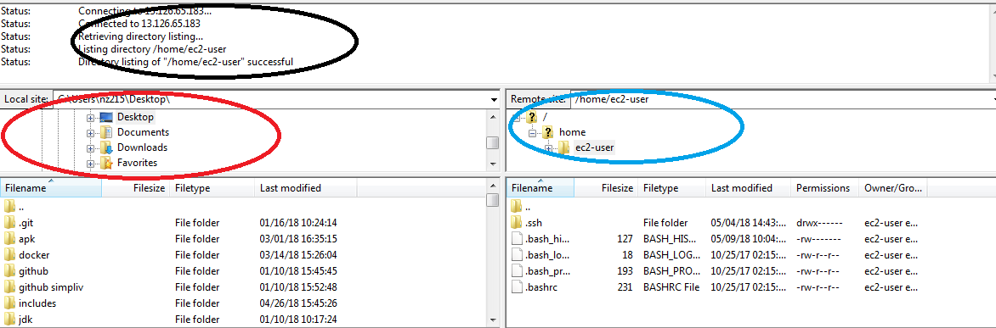

STEPS TO FILES TRANSFER USING WINSCP TO EC2 SERVER:

1. Open WinSCP to transfer files and choose Newsite Enter “hostname as ec2 IP address [13.126.65.183](https://ap-south-1.console.aws.amazon.com/ec2/v2/home?region=ap-south-1#Addresses:search=13.126.65.183;sort=publicIp)” and specify “ USERNAME AS EC2-USER”.

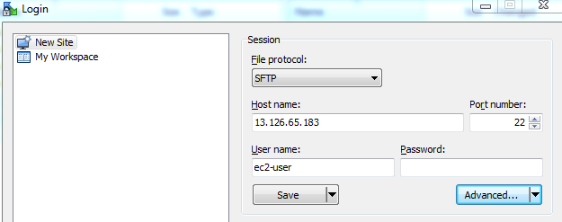

1. To Enter password, we need to add Ec2 server keypair to login to Ec2 server. “choose Advanced 🡪 go to SSH section and choose Authentication 🡪 Browse for ofbiz.ppk key pair and add it to WinSCP and click OK and Login.

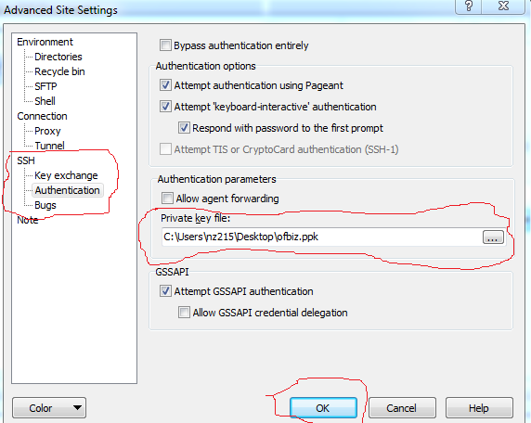

1. Choose login and now we connected successfully to local site to Ec2 remote site server. Now we can transfer files to to Ec2 server.

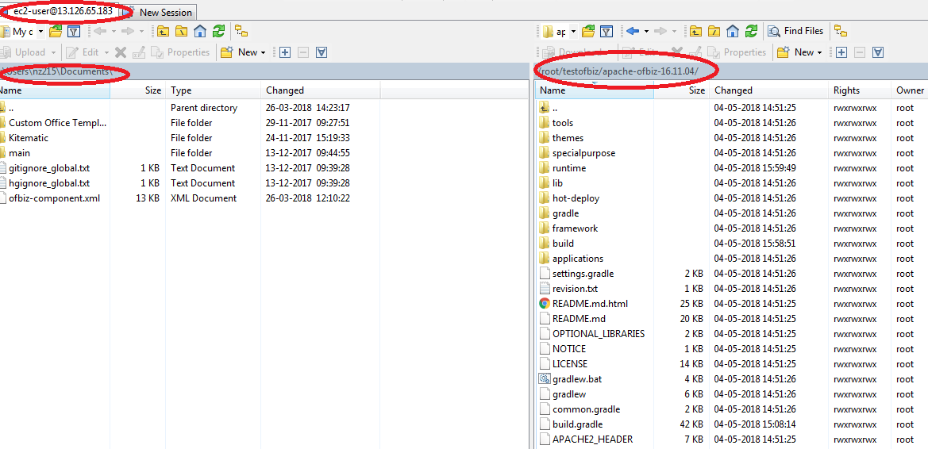

ERRORS AND DEBUG:

1. How to Debug the permission denied error while transfer files to Ec2 server from WinSCP or FileZilla?

There are two different folders called the "root" folder: / (the [root of the filesystem](https://en.wikipedia.org/wiki/Root_directory), which is really the only folder that should ever be called the "root folder"), and /root (the [root user](https://en.wikipedia.org/wiki/Superuser#Unix_and_Unix-like)'s [home directory](https://en.wikipedia.org/wiki/Home_directory)). During the normal course of operation (i.e., except while performing administrative tasks), users cannot create new files in / or /root.

Simply we need to give permission to the “Root folder by using command “SUDO CHMOD -R 777 /ROOT”. After changing permission, we can transfer files to root or any other folder using WinSCP or FileZilla.

1. How to Debug the “JOB FOR HTTPD.SERVICE FAILED ERROR IN APACHE?”

Sometimes we will get the HTTPD service failed because we need to install SSL certificates and we need to set the path correctly under httpd.conf file or ssl.conf files.

C:\Users\nz215\Desktop\ssl.PNG

To debug this error simply we need to add the SSL certs like “ [www.newstallc.com.crt](http://www.newstallc.com.crt) and [www.newsatllc.com.key](http://www.newsatllc.com.key) “. We need add this two SSL certs files under the httpd.conf file or SSL.conf file under “ SSLENGINEON section.

After adding the SSL certs, we need to Reload the apache using command “service httpd reload” and we need to restart the apache webserver using “service httpd restart”.

1. How to Debug the Segmentation fault error in Ec2 Linux while starting apache webserver or any services?

A segmentation fault error is the result of a Memory access violation. The program has referred to a memory address outside of what was allocated to it, and the OS kernel responds by killing the program with SIGSEGV.

A SIGSEGV is an error(signal) caused by an invalid memory reference or a segmentation fault. You are probably trying to access an array element out of bounds or trying to use too much memory.

To Debug this error, we need to Run the program called the “GDB”.

And we need to install HTTPD using GDB using command “DEBUGINFO -INSTALL HTTPD”.

We can Debug segmentation fault error using a command “GDB HTTPD”. And we need to check the memory of server using COMMAND “df -h”.

1. How to check storage space, memory information, CPU information free memory and giving permissions to folders in Ec2 Linux server using commands?

1. df -h: The df -h command is using to check disk storage space in Ec2 Linux server.

Output:

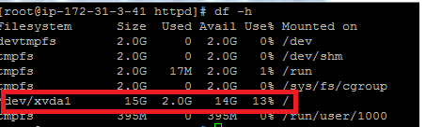

1. To check memory information, we need to open “mem info” file under cd /proc/mem info. Open file by using “Nano mem info”.

Output:

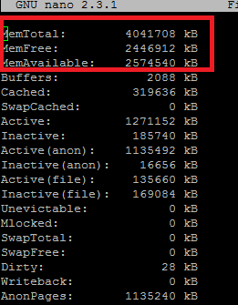

1. To check CPU information, we need to open “CPUINFO” file under cd /proc/CPU info. Open file using Nano CPU info.

Output:

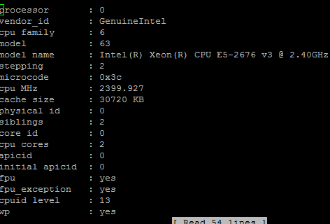

1. Free memory:

To check free memory, we need to use free -m command.

Output:

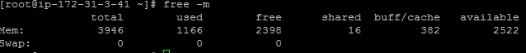

1. Permissions to folders:

To give permission to access folders with FileZilla or WinSCP. We need to use command “sudo chmod -R 777 folder name”. if want check permission or give or not we need to use command “ls -lrt”.

In output we will see the RWXRWXRWX 🡪 MEANS “READ, WRITE, EXECUTE PERMISSIONS ARE GIVEN TO FILES.

AND WE WILL SEE DRWXWXRWXW 🡪 MEANS “DIRECTORY HAVING THE READ, WRITE, EXECUTE AND ACCESS PERMISSIONS.

Output:

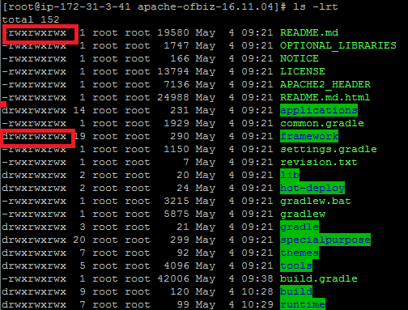

1. HOW TO RUN A PROJECT IN BACKGROUND AFTER CLOSING EC2 instance Terminal?

To run a project in background we need to use “NOHUP” command. We can run NOHUP with our project command in background

NOHUP SYNTAX COMMAND:

“NOHUP. /GRADLEW OFBIZ &” IS USED TO RUN A PROJECT IN BACKGROUND.

Where,

* **command-name**: is name of shell script or command name. You can pass argument to command or a shell script.
* **&**: NOHUP does not automatically put the command it runs in the background; you must do that explicitly, by ending the command line with an & symbol.

1. HOW TO DEBUG JAVA INSUFFICENT MEMORY ERROR IN EC2 LINUX SERVER?

To debug, Java insufficient memory error in Ec2. we need to add Swap memory or to increase the Ram for the Ec2 instance.

we will add swap memory to Ec2 instance server by using commands below:

sudo /bin/dd if=/dev/zero of=/var/swap.1 bs=1M count=1024--🡪 1GB

sudo /sbin/mkswap /var/swap.1

sudo chmod 600 /var/swap.1

we need to add swap file to cd /etc/swapmem.file.

sudo /sbin/swapon /var/swap.1

And we need to increase JAVA HEAP SIZE IN JAVA FILE like below:

java -XX: +PrintFlagsFinal -Xms512m -Xmx1024m -Xss512k -XX:PermSize=64m -XX:MaxPermSize=128m

if we want to export the java heap size to file we need to add export command:

export java -XX: +PrintFlagsFinal -Xms512m -Xmx1024m -Xss512k -XX:PermSize=64m -XX:MaxPermSize=128m

To increase the RAM size for instance to avoid memory error:

* 1. Go to EC2 instance in aws console and stop the EC2 running server.
  2. Go to actions🡪 choose instance settings 🡪 choose change instance type.
  3. And choose t2. medium which will have memory RAM.
  4. And start the EC2 server after changing the instance type.
  5. Now, we have 2gb RAM for Ec2 instance.

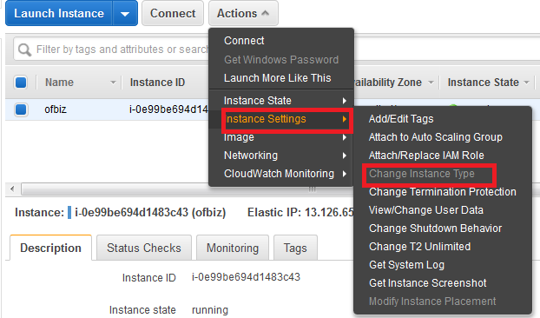

Modifying the EC2 instances volumes:

If we need to more storage space for project we need to increase / modify the volumes for EC2 server.

Steps:

1. Go to Ec2 services and in left panel under “ELASTIC BLOCK STORAGE” we will see volumes and Click on volumes.
2. Go to actions and choose modify volumes.

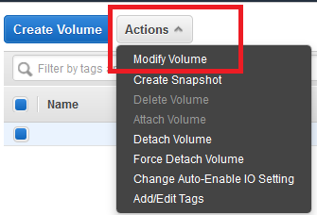

1. Specify the how much storage space we want under size columns and click on modify we will get Message “SUUCCESSFULLY MODIFIED.”

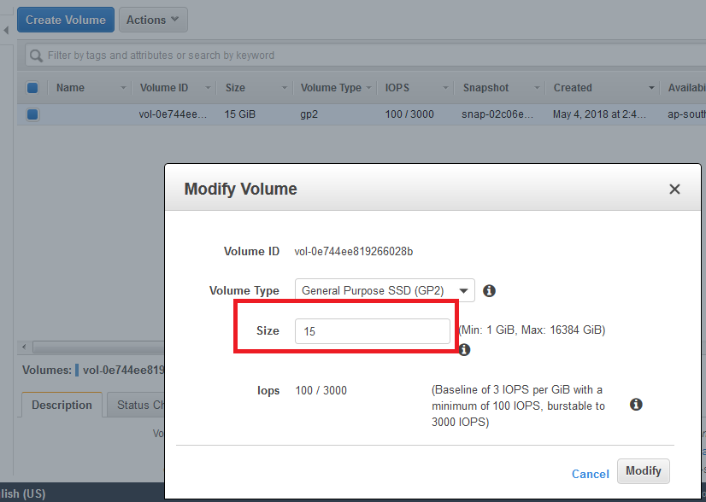

1. After volume modify we need to stop and start the EC2 instance server.
2. And login to Ec2 server and check the volumes is increased or not by using command “DF -H”.

COMMANDS TO FIND LINUX OS VERSION, OS BIT OF VERSION, CPU UTILIZATION AND MEMORY OF LINUX, FIND PRESENT WORKIND DRIECTORY, AND HOW TO CREATE DIRECTORIES AND CREATE OWN FILES, AND HOW TO OPEN FILES IN LINUX AND COPY FILES FROM ONE LOCATION TO ANOTHER LOCATION:

1. UNAME -R: This command is useful to find the Linux OS version.
2. Cat/etc*release: This command also useful to show the Linux Ec2 instance kernel version and home of Ec2 server and detailed os version.
3. TOP: This top command is useful to see the what are the running process and how much all the services are occupying memory and Ram we check it.
4. PWD: This PWD command is using to check our present working directory When you first open the terminal, you are in the home directory of your user. To know which directory you are in, you can use the **“pwd”** command. It gives us the absolute path, which means the path that starts from the root. The root is the base of the Linux file system. It is denoted by a forward slash (/). The user directory is usually something like "/home/username".

OUTPUT:

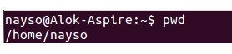

1. TOUCH: This command is useful to create our own files in Linux OS. The**touch** command is used to create a file. It can be anything, from an empty txt file to an empty zip file. For example, “**touch new.txt**”.

OUTPUT:

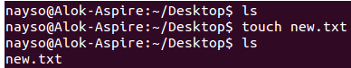

1. MKDIR: Use the **mkdir** command when you need to create a folder or a directory. For example, if you want to make a directory called “DIY”, then you can type **“mkdir DIY**”. Remember, as told before, if you want to create a directory named “DIY Hacking”, then you can type “mkdir **DIY\ Hacking**”. Use **rmdir** to delete a directory. But **rmdir** can only be used to delete an empty directory. To delete a directory containing files, use **rm**.

OUTPUT:

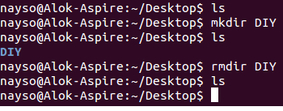

1. LS: Use the **"Is"** command to know what files are in the directory you are in. You can see all the hidden files by using the command **“ls -a”**.

OUTPUT:

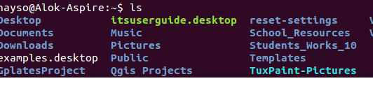

1. RM:  Use the **rm** command to delete files and directories. But **rm** cannot simply delete a directory. Use “**rm -r**” to delete a directory. In this case, it deletes both the folder and the files in it.

OUTPUT:

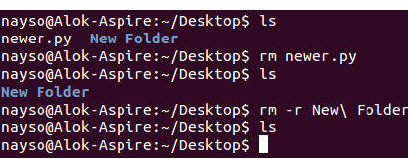

1. MAN&--HELP: To know more about a command and how to use it, use the **man** command. It shows the manual pages of the command. For example, “**man cd**” shows the manual pages of the **cd**command. Typing in the command name and the argument helps it show which ways the command can be used (e.g., **cd –help**).

OUTPUT:

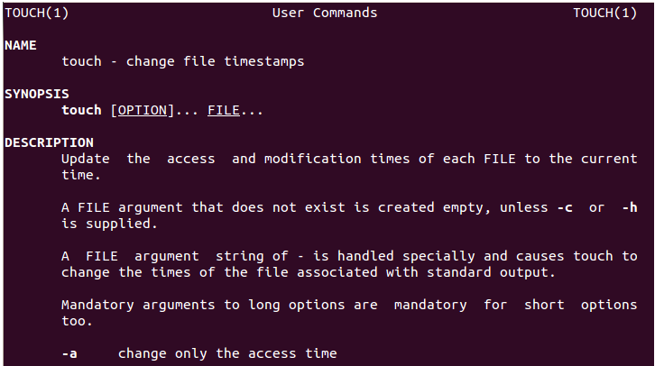

1. CP: Use the **cp**command to copy files through the command line. It takes two arguments: The first is the location of the file to be copied, the second is where to copy.

OUTPUT:

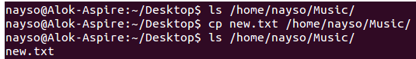

11.MV: Use the **mv** command to move files through the command line. We can also use the **mv** command to rename a file. For example, if we want to rename the file “**text**” to “**new**”, we can use “**mv text new**”. It takes the two arguments, just like the**cp** command.

OUTPUT:

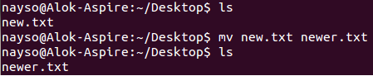

1. LOCATE: The **locate** command is used to locate a file in a Linux system, just like the search command in Windows. This command is useful when you don't know where a file is saved or the actual name of the file. Using the -i argument with the command helps to ignore the case (it doesn't matter if it is uppercase or lowercase). So, if you want a file that has the word “hello”, it gives the list of all the files in your Linux system containing the word "hello" when you type in “**locate -i hello**”. If you remember two words, you can separate them using an asterisk (*). For example, to locate a file containing the words "hello" and "this", you can use the command “**locate -i *hello*this”.**

OUTPUT:

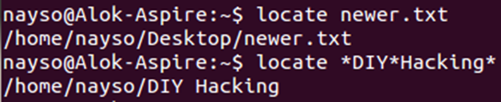

1. CAT:

Use the **cat** command to display the contents of a file. It is usually used to easily view programs.

OUTPUT:

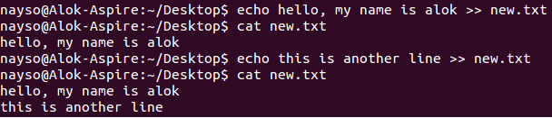

1. NANO VI& JED: **nano** and **vi** are already installed text editors in the Linux command line. The **nano** command is a good text editor that denotes keywords with color and can recognize most languages. And **vi** is simpler than **nano**. You can create a new file or modify a file using this editor. For example, if you need to make a new file named **"check.txt**", you can create it by using the command “**nano check.txt**”. You can save your files after editing by using the sequence Ctrl+X, then Y (or N for no). In my experience, using **nano**for HTML editing doesn't seem as good, because of its color, so I recommend **jed**text editor. We will come to installing packages soon.

OUTPUT:

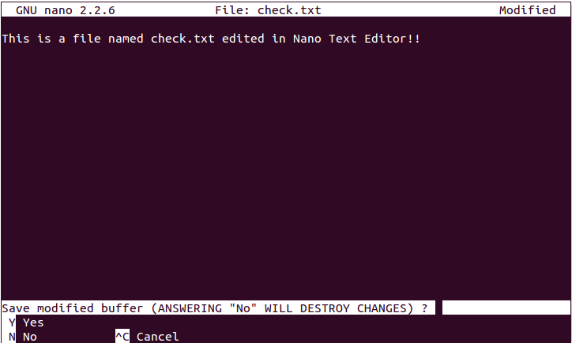

1. HOSTNAME: Use **hostname** to know your name in your host or network. Basically, it displays your hostname and IP address. Just typing “**hostname**” gives the output. Typing in “**hostname -I**” gives you your IP address in your network.

OUTPUT:

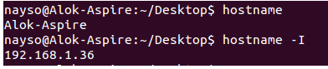

15.PING: Use **ping** to check your connection to a server. Wikipedia says, "**Ping**is a computer network administration software utility used to test the reachability of a host on an Internet Protocol (IP) network". Simply, when you type in, for example, “**ping google.com**”, it checks if it can connect to the server and come back.

OUTPUT:

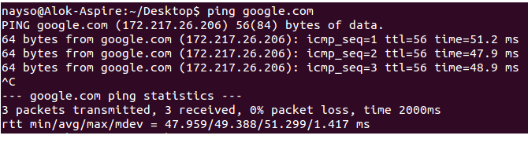

***Tips and Tricks for Using Linux Command Line***

* You can use the **clear** command to clear the terminal if it gets filled up with too many commands.
* **TAB** can be used to fill up in terminal. For example, you just need to type “**cd Doc**” and then **TAB** and the terminal fills the rest up and makes it “**cd Documents**”.
* **Ctrl+C** can be used to stop any command in terminal safely. If it doesn't stop with that, then **Ctrl+Z** can be used to force stop it.
* You can exit from the terminal by using the **exit** command.
* You can power off or reboot the computer by using the command **sudo halt**and **sudo reboot**.